Narrogin Senior High School
AEBLY Biological Sciences

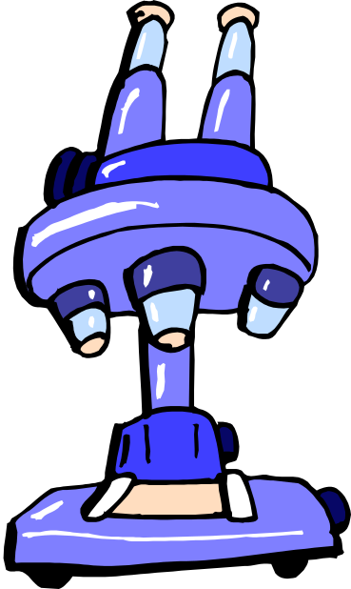

Task 2

Science Inquiry Test

30 marks
Instructions.
Students are to be supervised and complete this task under test conditions. Students need to be supplied with graph paper and lined paper. Multichoice answers need to be completed on the multichoice answer sheet. Students may use a ruler, blue pen, pencil and a non programmable calculator.

Biology
Test
Total 45 Marks

1. An experiment with a control group is used in testing a hypothesis because it

(a) helps to ensure that the results can be compared with a standard set of figures
(b) is needed to design the experiment properly
(c) depends on the trial and error method
(d) tests all aspects of the problem under investigation.

2. A good way to test a hypothesis is to

(a) design an experiment
(b) form a theory
(c) examine the facts
(d) test the facts in relation to each other

3. Louis Pasteur while watching bacteria noted that they stopped moving when they came close to the edge of the water droplet they were immersed in. He guessed that this could be due to the amount of oxygen present in the water near where it came into contact with the air. The process involved in making this guess is best described as

(a) forming a hypothesis
(b) reaching a conclusion
(c) developing a theory
(d) making a generalisation

Three groups of hamsters were tested daily in a maze. The route through the maze forked many times and none of the choices were repeated. The number of errors each hamster made was recorded and an average calculated. One group of hamsters received no reward when they reached the end of the maze. One of the groups received regular rewards and the third group received a reward on the third day.

The results were graphed and looked like this:
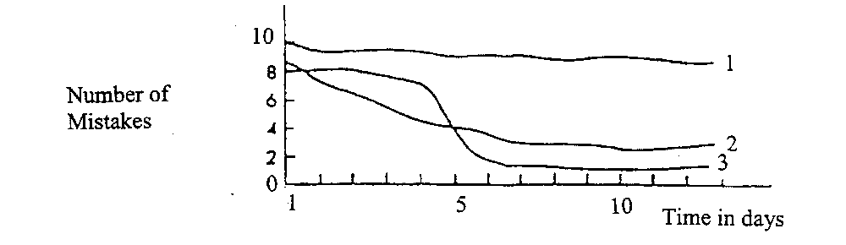
4. Which group of hamsters did not receive any reward?
(a) hamster group 1
(b) hamster group 2
(c) hamster group 3
(d) none

5. What is the independent variable for this experiment?

(a) amount of reward
(b) timing of reward
(c) hamster group
(d) type of maze

6. Which group produced the most mistakes over the course of the trials?

(a) hamster group 1
(b) hamster group 2
(c) hamster group 3
(d) all groups

A biologist took two identical hairy leafed plants. She shaved the hairs off one of the plants and placed both plants into a glass enclosure. The plants were exposed to the same conditions, that is, constant humidity and temperature, no water and were exposed to light continuously for two days. The plants were weighed before the experiment began and again after two days.

 | INITIAL WEIGHT | FINAL WEIGHT
PLANT A (NO hairs) | 218.9 g | 200.3 g
PLANT B (hairs) | 214.7 g | 200.9 g

7. The independent(manipulated) variable in the above experiment is

(a) weight of the plants
(b) shaving the hairs off one plant
(c) water content of the plants
(d) amount of light

8. The control group for the experiment was

(a) unshaven plant
(b) regulated atmosphere
(c) continuous exposure to light
(d) lack of water

9. Which of the following statements is an observation

(a) the more water a plant receives the faster it grows
(b) “that plant has grown 3 cm in one week”
(c) all plants need to photosynthesize
(d) plants grow taller when they are fertilized.

10. A hypothesis can be defined as

(a) a law which has a limited application
(b) a fact derived from experimentation
(c) a conclusion reached from a group of theories
(d) a likely answer to a question based on observations.

11. Is the statement ‘ an increase in salt concentration will decrease cell sizes’ a

(a) theory
(b) hypothesis
(c) result
(d) experimental design

The following table of data was collected using a large sample of students.

HEIGHT GAIN (cm/year) |  | AGE
FEMALES | MALES
6 | 6.1 | 6
5.5 | 5.7 | 8
5.2 | 5.3 | 10
8.3 | 5 | 12
2.6 | 9 | 14
0.7 | 2.7 | 16
0.2 | 0.6 | 18

12 What type of graph would best show the data recorded above?

(a) line graph
(b) histogram
(c) bar graph
(d) column graph

- A biologist is given the task of determining the cause of a certain disease in a population of native Australian hopping mice.
Which of the following would not be an acceptable way of conducting a research investigation into this problem.

(a) Carry out a preliminary study on the mice in their natural habitat in order to define a research hypothesis
(b) Consult scientific journals and attempt to reproduce the results of a previous related experiments
(c) Reject experimental or observational evidence, which does not support a particular hypothesis under investigation.
(d) Conduct a series of suitable controlled experiments, to eliminate variables not suspected of causing the disease

14 A scientific theory is

(a) An idea which has not been tested
- An unsupported hypothesis
(c) A generally accepted hypothesis which is supported by a available evidence
(d) A proven hypothesis

Scientists were investigating the effect of a high phosphate fertilizer on the growth of Eucalyptus seedlings.
Different amounts of fertilizer were applied to the first three plots; none was applied to the fourth. Each plot was planted with 200 seedlings and all important, potential variables were controlled.

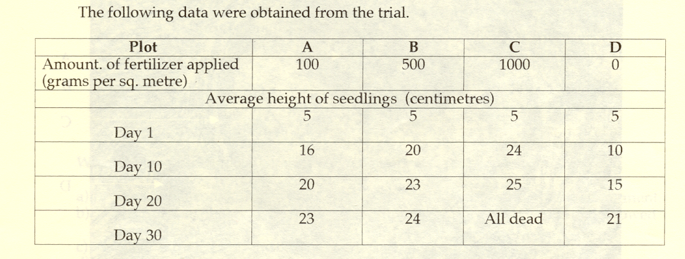

- In the above investigation, the control procedure was

- Plot A
- Plot B
- Plot C
- Plot D

Part B Short Answer
1 A student attempting to determine the effect of the lack of soil fungus on the growth
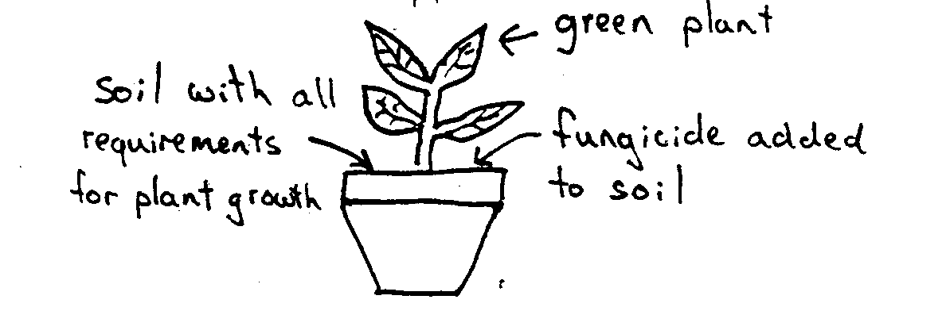
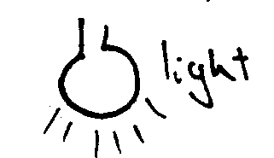
of a plant species set up the following experiment.

After one week the student checked the condition of the plant (note - fungicide is a pesticide that kills fungi).

i) What important component of the experiment is missing? (1 mark)

___________________________________________________________________________
___________________________________________________________________________

ii) Why is this component important? (1 marks)
___________________________________________________________________________
___________________________________________________________________________
iii) Explain how this experiment could be improved. Outline the method you would use (include method of increasing the validity of results collected).(2 marks)

iv) State a hypothesis that the experiment could be testing? (2 marks)

v) What results would you require to support your hypothesis? (2 mark)

___________________________________________________________________________
___________________________________________________________________________
Total 8 marks

2. Duckweed is a small freshwater plant. Lemna gibba and Spirodela polyrhiza are two species of duckweed. A student placed populations of duckweed in two identical, controlled-environment ponds. Only Lemna gibba was placed in pond A. Equal amounts of Lemna gibba and Spirodela polyrhiza were placed in pond B. Each pond was provided with suitable nutrients for duckweed growth. Every week a square metre sample of plants growing on the surface of each pond was removed and the weight of Lemna gibba plants in each sample was measured. The samples were then returned to the ponds.
The following table shows the change in weight of Lemna gibba in pond A and in pond B over the eight weeks of the experiment.
a) Graph the above data (4 marks)
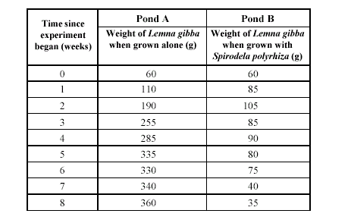
b) State one hypothesis that this experiment may have been designed to test.

__________________________________________________________________

__________________________________________________________________

(2 marks)
c) State the dependent variable in this experiment.

__________________________________________________________________

__________________________________________________________________

(1 marks)

Total 7 marks
Multichoice Answer Sheet Task 2

Name: __________________________________________

School: _________________________________________

Supervising teacher: ____________________________________

Circle the correct response

1 | A | B | C | D | 9 | A | B | C | D
2 | A | B | C | D | 10 | A | B | C | D
3 | A | B | C | D | 11 | A | B | C | D
4 | A | B | C | D | 12 | A | B | C | D
5 | A | B | C | D | 13 | A | B | C | D
6 | A | B | C | D | 14 | A | B | C | D
7 | A | B | C | D | 15 | A | B | C | D
8 | A | B | C | D

